Scenario: You are a scientist conducting research on rare elements found in a specific region. Your goal is to estimate the average concentration of a rare element in the region using a random sample of measurements. You will use the NumPy library to perform point estimation and calculate confidence intervals for the population mean.The rare element concentration data is stored in a CSV file named "rare_elements.csv," where each row contains a single measurement of the concentration.
Question: Write a Python program that allows the user to input the sample size, confidence level, and desired level of precision.

Solution:
import numpy as np import pandas as pd from scipy import stats import math
data = pd.read_csv("/content/rare_elements.csv") sample_size = int(input("Enter sample size: "))
confidence_level = float(input("Enter confidence level (e.g., 0.95): ")) precision = float(input("Enter desired level of precision (E): ")) sample = data.sample(n=sample_size, random_state=1) sample_mean = np.mean(sample["concentration"])
sample_std = np.std(sample["concentration"], ddof=1) z_score = stats.norm.ppf((1 + confidence_level) / 2)
margin_of_error = z_score * (sample_std / math.sqrt(sample_size)) lower_bound = sample_mean - margin_of_error
upper_bound = sample_mean + margin_of_error print("\n--- Estimation Results ---")
print(f"Sample Mean (Point Estimate): {sample_mean:.3f}") print(f"Confidence Level: {confidence_level * 100:.1f}%") print(f"Margin of Error: {margin_of_error:.3f}")
print(f"Confidence Interval: ({lower_bound:.3f}, {upper_bound:.3f})")

--- Estimation Results ---
Sample Mean (Point Estimate): 50.328 Confidence Level: 99.0%
Margin of Error: 3.486

Confidence Interval: (46.842, 53.814) if margin_of_error <= precision:
print("✔ Desired precision achieved.") else:
print("✖ Desired precision NOT achieved. Increase sample size.")
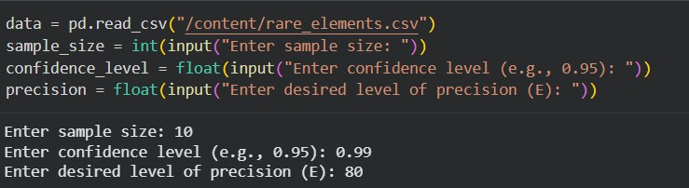

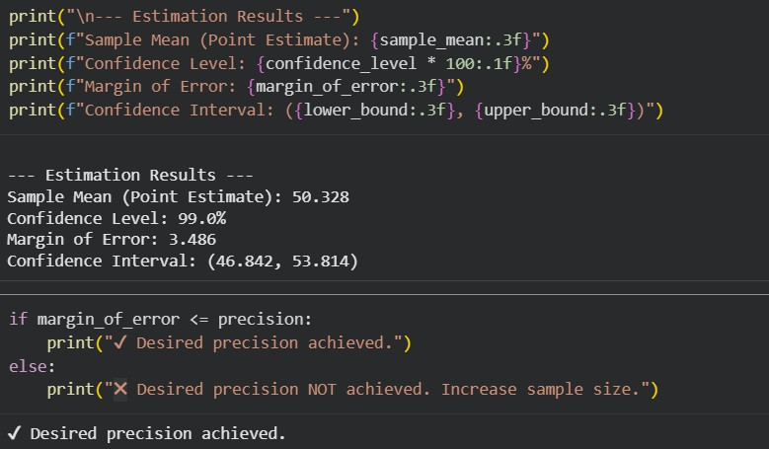

Scenario: Imagine you are an analyst for a popular online shopping website. Your task is to analyze customer reviews and provide insights on the average rating and customer satisfaction level for a specific product category.
Question: You will use the pandas library to calculate confidence intervals to estimate the true population mean rating. You have been provided with a CSV file named "customer_reviews.csv," which contains customer ratings for products in the chosen category.

Solution:
import pandas as pd import numpy as np from scipy import stats import math
df = pd.read_csv("/content/customer_reviews.csv") confidence_level = 0.95
sample_mean = df["rating"].mean() sample_std = df["rating"].std() sample_size = df["rating"].count()
z_score = stats.norm.ppf((1 + confidence_level) / 2) margin_of_error = z_score * (sample_std / math.sqrt(sample_size)) lower_bound = sample_mean - margin_of_error
upper_bound = sample_mean + margin_of_error
print("Average Rating (Point Estimate):", round(sample_mean, 2)) print("Confidence Level:", confidence_level * 100, "%")
print("Confidence Interval:", (round(lower_bound, 2), round(upper_bound, 2)))
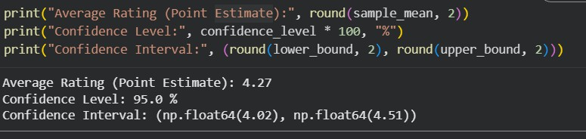

Question: You are a real estate analyst trying to predict housing prices based on various features of the houses, such as area, number of bedrooms, and location. You have collected a dataset of houses with their respective prices. Write a Python program that allows the user to input the features (area, number of bedrooms, etc.) of a new house. The program should use linear regression from scikit- learn to predict the price of the new house based on the input features.

Solution:
import pandas as pd
from sklearn.linear_model import LinearRegression df = pd.read_excel("House_Prediction.xlsx")
X = df[["beds", "baths", "size", "zip_code"]] y = df["price"]
model = LinearRegression() model.fit(X, y)
beds = float(input("Number of bedrooms: ")) baths = float(input("Number of bathrooms: ")) size = float(input("House size (in sq ft): ")) zip_code = float(input("ZIP code: "))
new_house = pd.DataFrame([[beds, baths, size, zip_code]], columns=["beds", "baths", "size", "zip_code"])
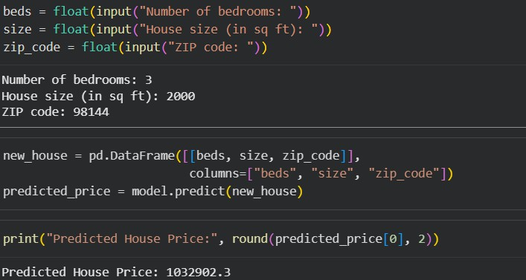
predicted_price = model.predict(new_house) print("Predicted House Price:", round(predicted_price[0], 2))

Question: You are working for a telecommunications company, and you want to predict whether a customer will churn (leave the company) based on their usage patterns and demographic data. You have collected a dataset of past customers with their churn status (0 for not churned, 1 for churned) and various features. Write a Python program that allows the user to input the features (e.g., usage minutes, contract duration) of a new customer. The program should use logistic regression from scikit-learn to predict whether the new customer will churn or not based on the input features.

Solution:
import pandas as pd
from sklearn.linear_model import LogisticRegression df = pd.read_csv("customer_churn.csv")
X = df[["usage_minutes", "contract_months", "monthly_charges"]] y = df["churn"]
model = LogisticRegression() model.fit(X, y)
usage = float(input("Enter usage minutes: "))
contract = float(input("Enter contract duration (months): ")) charges = float(input("Enter monthly charges: ")) new_customer = pd.DataFrame([[usage, contract, charges]],
columns=["usage_minutes", "contract_months", "monthly_charges"]) prediction = model.predict(new_customer)
if prediction[0] == 1: print("Customer is likely to churn")
else:
print("Customer is not likely to churn")
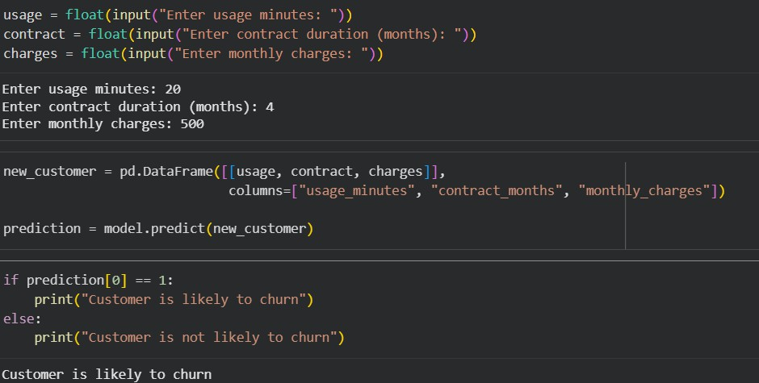

Scenario: You work as a data scientist for an automobile company that sells various car models. The company has collected data on different car attributes, such as engine size,horsepower, fuel efficiency, and more, along with their corresponding prices. The marketing team wants to build a predictive model to estimate the price of cars based on their features.
Question: Your task is write a Python program that perform linear regression modeling to predict car prices based on a selected set of features from the dataset. Additionally, you need to evaluate the model's performance and provide insights to the marketing team to understand the most influential factors affecting car prices.

Solution:
import pandas as pd
from sklearn.model_selection import train_test_split from sklearn.linear_model import LinearRegression
from sklearn.metrics import r2_score, mean_absolute_error

df = pd.read_csv("Fuel_Efficiency datasets.csv")

X = df[["cylinders", "displacement", "highway_mpg", "year"]] y = df["city_mpg"]

X_train, X_test, y_train, y_test = train_test_split( X, y, test_size=0.2, random_state=42
)

model = LinearRegression() model.fit(X_train, y_train)

y_pred = model.predict(X_test)

print("R2 Score:", round(r2_score(y_test, y_pred), 3))
print("Mean Absolute Error:", round(mean_absolute_error(y_test, y_pred), 2))

cylinders = float(input("Enter cylinders: ")) displacement = float(input("Enter displacement: ")) highway_mpg = float(input("Enter highway mpg: "))

year = int(input("Enter model year: "))

new_car = pd.DataFrame(
[[cylinders, displacement, highway_mpg, year]], columns=["cylinders", "displacement", "highway_mpg", "year"]
)

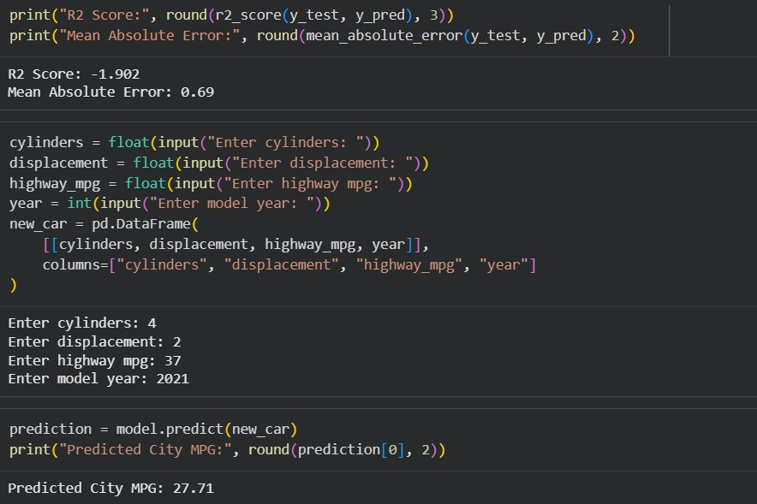
prediction = model.predict(new_car) print("Predicted City MPG:", round(prediction[0], 2))

